11/15/23

Griffin Rzonca

ESP32 Tests

* Built in LED works, can alter example program and upload code, but struggle with GPIO
* Same problem: [ESP32 pin output not working with Arduino IDE - Stack Overflow](https://stackoverflow.com/questions/47739950/esp32-pin-output-not-working-with-arduino-ide)
  + Pinout may be the issue
* Appears that every pin number actually controls the metal piece above it, NOT the hole adjacent to it
* Code stays on ESP32 even after being unplugged from computer so long as power is running to it, just as expected
* AD9850 Can receive 3.3V power, light turns on
* Can get outputs to pins, but struggling to interface with libraries since they were written for Arduino, not ESP32
* [HC-SR08 - AD9850 Signal Generator Module (electronicoscaldas.com)](https://www.electronicoscaldas.com/datasheet/HC-SR08.pdf) - Basic AD9850 info and interfacing with MCU
* Library: [AD9850/examples/AD9850/AD9850.ino at master · F4GOJ/AD9850 · GitHub](https://github.com/F4GOJ/AD9850/blob/master/examples/AD9850/AD9850.ino)
* I can control and rename the pins, and can change the outputs, but can’t get the library functions to work
* Consider doing clocking and word loading manually even if it is extremely inefficient
* When I run the program, the output begins at 0V, but then updates to 3.3V after around 10 seconds. Something in the ESP32 is creating this output, but it is a constant 3.3V instead of a sine/square wave. Why?

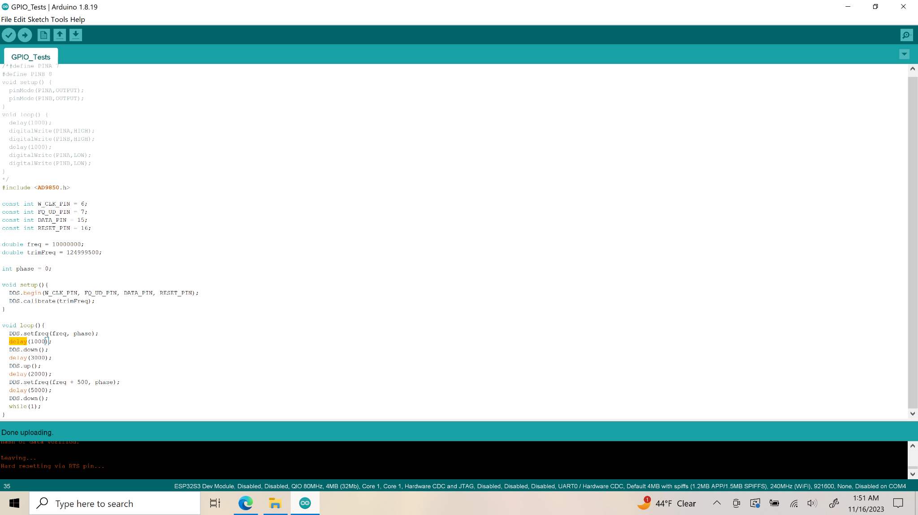

* Voltage updates from 0 to a constant 3.3V after this delay. Can control how long it takes
* Down function brings output voltage to 3.3V, up function sets it to 0V
* Output works! At least the sine wave output pin does (Pin Sine Wave Out 1), able to generate a 281.2KHz (and up to 10MHz) sine wave output using the code saved
  + Still need to work on square wave though
  + Tests for resonance varied from 278-282kHz roughly, best results when using “single” on oscilloscope
* AD9850 takes 3.3V, 0.06A current draw from supply
* Use “GPIO Tests” file for most recent code, uses this library: [GitHub - F4GOJ/AD9850: AD9850 serial library for arduino](https://github.com/F4GOJ/AD9850/tree/master)
* Next time, try to fix square wave generation, then will be good to go!